**Plotting of 3D Surfaces**

Scilab can be used to plot surfaces and curves in space, with many options for the treatment of hidden faces, face colors, points of view, etc. The following examples will illustrate 3-D plots.

The surf function can be used for plotting surfaces. This function has three input variables, **x, y** and **z**. **x** and **y** are respectively vectors of size 𝑚 and 𝑛 corresponding to points on the axes (𝑂𝑥) and (𝑂𝑦). **z** is a matrix of dimension 𝑛×𝑚 with element 𝑧!" corresponding to the height of the point with X-coordinate  and Y-coordinate .

To plot the surface defined by a function of the form 𝑧 = (𝑥, 𝑦), it is necessary to :

* Define function 𝑓
* Calculate **z=feval(x,y,f)'**

**feval(x,y,f)** returns the 𝑚×𝑛 matrix whose 𝑖𝑗 element is 𝑓() which will betransposed by using the single quote symbol “ ' “

* Execute **surf(x,y,z).**

The programming commands are as follows:

**For Plane-**

function z=f(x,y)

z=4+x+y;

endfunction

x=linspace(-2,2,100);

y=linspace(-2,2,200);

z=feval(x,y,f)';

clf

surf(x,y,z)

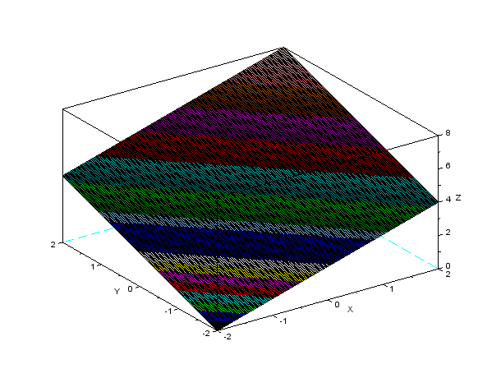

Figure 1: Plane (x+y-z=1)

**For semi sphere-**

function z=f(x,y)

z=sqrt(4-x^2-y^2);

endfunction

x=linspace(-2,2,100);

y=linspace(-2,2,200);

z=feval(x,y,f)';

clf

surf(x,y,z)

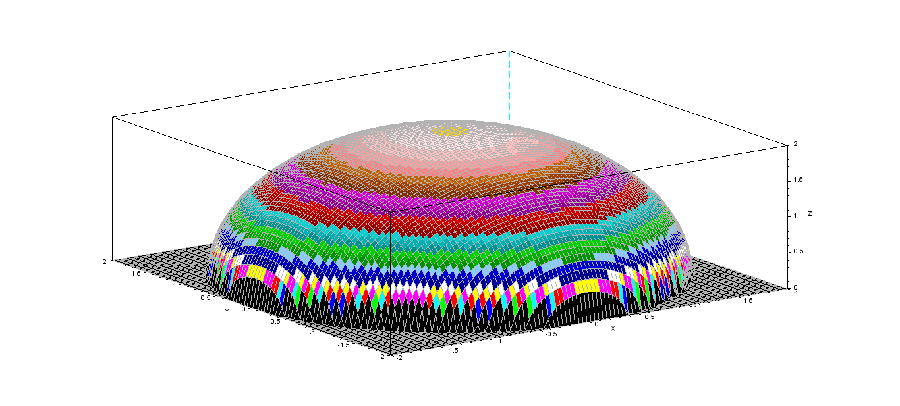

Figure 2: Semi Sphere(x^2+y^2+z^2=4)

**For sphere-**

a =linspace(0,360,100);

th=linspace(-90,90,50);

R =1;

[A,Th]=meshgrid(a,th);

Z = R*sind(Th);

X = R*cosd(Th).*cosd(A);

Y = R*cosd(Th).*sind(A);

Ncolors=100; *// Number of coding colors*

clf

surf(X,Y,Z)

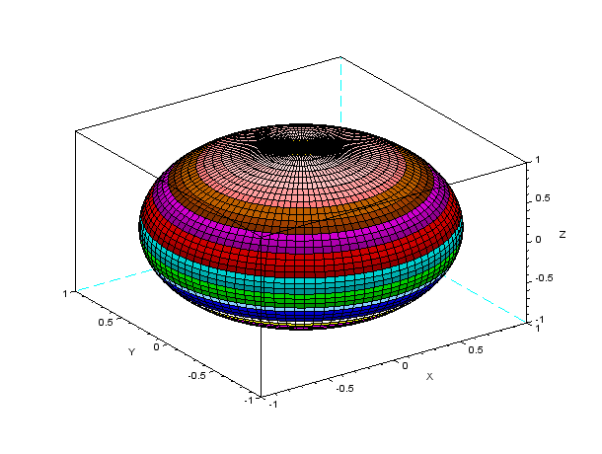

Figure 3: Sphere (x^2+y^2+z^2=1)

**For Cylinder (Half)**

r=linspace(0,1,100);

th=linspace(-90,90,50);

[R,Th]=meshgrid(r,th);

Z =R;

X =cosd(Th);

Y =sind(Th);

Ncolors=100; *// Number of coding colors*

clf

plot3d(X,Y,Z)

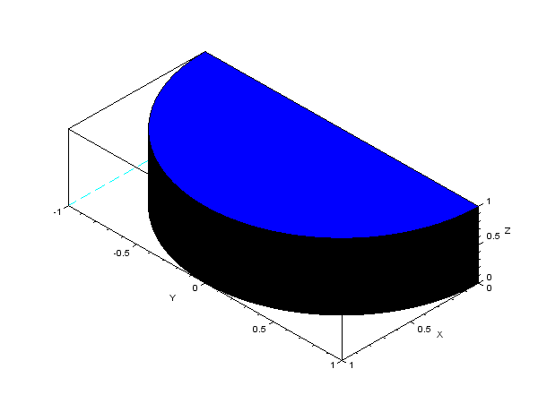

Figure 4: Cylinder (x^2+y^2=1 and z= to z=1)

**Complete Cylinder**

t=linspace(0,2*%pi,100);

x1=linspace(0,4,100);

[T,X1]=meshgrid(t,x1);

x=2*cos(T);y=2*sin(T);z=f(X1);

surf(x,y,z)

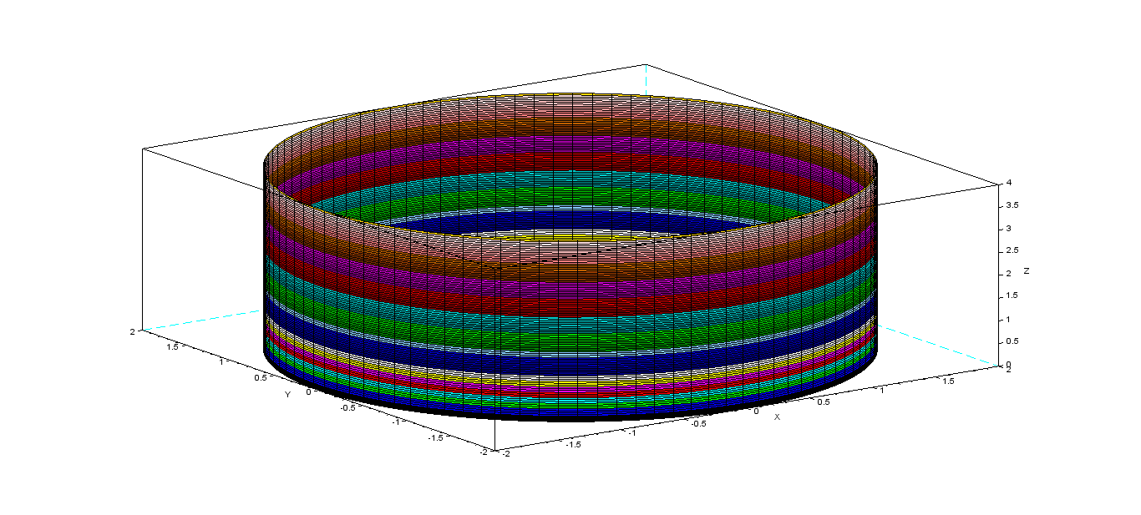

**Figure 5:Cylinder x^2+y^2=4; z=0 to z=4**

**For Paraboloid-**

function z=f(x,y)

z=x^2+y^2;

endfunction

x=linspace(-1,1,100);

y=linspace(-1,1,200);

z=feval(x,y,f)';

clf

surf(x,y,z)

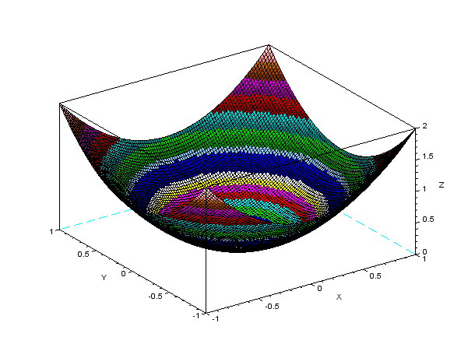

Figure 6 :Paraboloid (z=x^2+y^2)

**For Ellipsoid-**

a =linspace(0,360,100);

th=linspace(-90,90,50);

R =1;

[A,Th]=meshgrid(a,th);

Z =2*R*sind(Th);

X =3*R*cosd(Th).*cosd(A);

Y =2*R*cosd(Th).*sind(A);

Ncolors=100; *// Number of coding colors*

clf

surf(X,Y,Z)

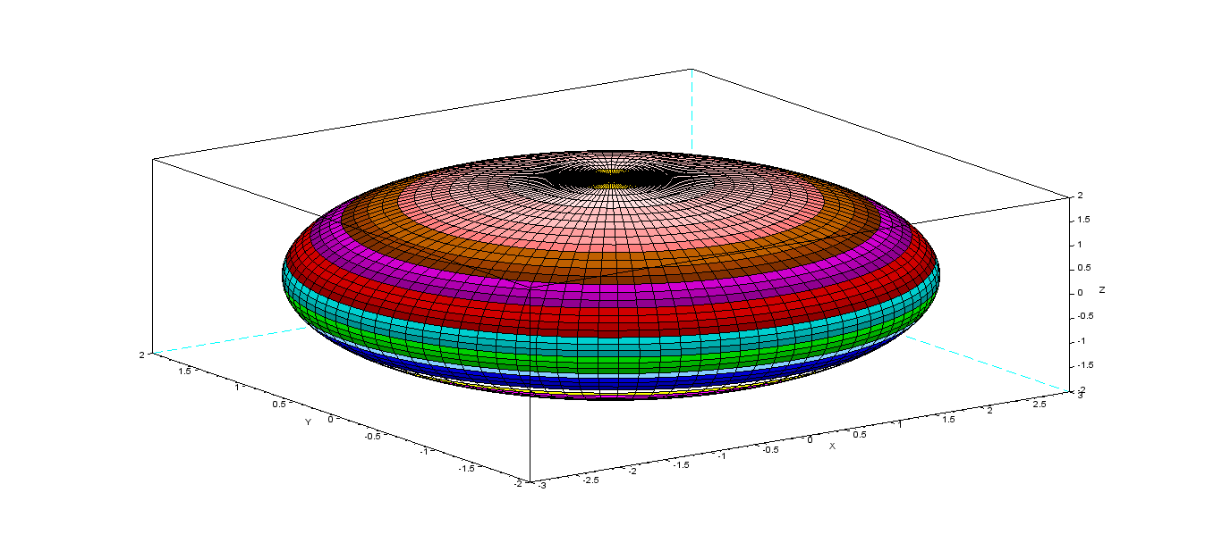

Figure 7:Ellipsoid (x^2/9+y^2/4+z^2/4=1)

**For Hyperbola-**

a =linspace(0,360,100);

th=linspace(-90,90,50);

R =1;

[A,Th]=meshgrid(a,th);

Z =2*R*sinh(Th);

X =3*R*cosh(Th).*cosd(A);

Y =2*R*cosh(Th).*sind(A);

Ncolors=100; *// Number of coding colors*

clf

surf(X,Y,Z)

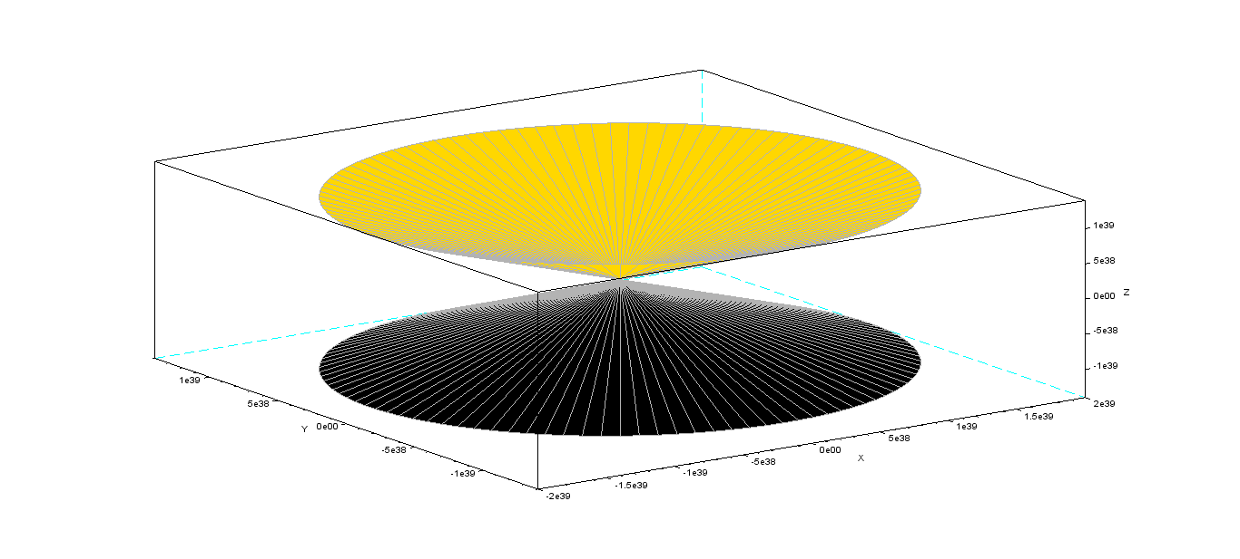

Figure 8: x^2/9+y^2/4-z^2/4=1

**For Cone-**

function z=f(x,y)

z=sqrt(x^2/4+y^2/9);

endfunction

x=linspace(-300,300,50);

y=linspace(-300,300,50);

z=feval(x,y,f)';

clf

surf(x,y,z)

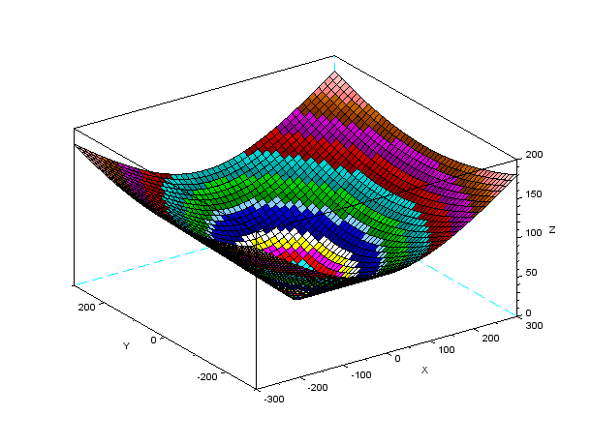

Figure 9:Cone(z^2=x^2/4+y^2/9)